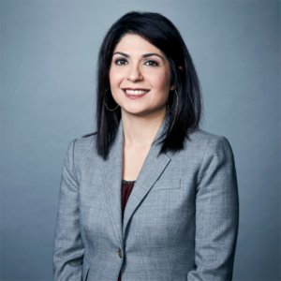
Samira Jafari, Executive Editor of The Row, CNN's editorial oversight team
Samira Jafari serves as Executive Editor of The Row, CNN’s editorial oversight team that is responsible for script and story approval across all platforms worldwide. Her team ensures that stories meet high standards of storytelling, clarity, accuracy, quality, fairness and balance, while avoiding libel, defamation and use infringement issues. She has overseen the editorial integrity of several award-winning investigative projects, including “Beneath the Skin,” CNN’s year-long investigation into the controversial police shooting of a black teen in Chicago. She has also discussed how to “Maintain Trust in a Polarized World” -- a look at what journalists can do cut through the partisan noise and cultivate trust with their digitally savvy audiences -- at several conferences, including the Business of Truth Forum in Johannesburg, South Africa, and the annual Georgia Bar Media Conference in Atlanta.
Jafari has been at CNN for more than a decade, previously serving as a supervising news editor. She is also a former Correspondent for the Associated Press. A University of Georgia graduate, she is a proud member of the Georgia First Amendment Foundation Board of Directors and Vice Chair of the Board of the The Red & Black, an independent student newspaper serving the University of Georgia community.
She was born in Tehran and immigrated to the United States with her parents in 1984.

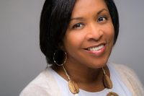
Sonya Ross, Managing partner and editor-in-chief, Black Women Unmuted
Sonya Ross is managing partner and editor-in-chief of Black Women Unmuted, an independent media start-up that provides political coverage of black women in the US through the 2020 election cycle.
Sonya launched BWU in 2019 after a 33-year career at The Associated Press that took her on assignment to 48 countries and all 50 states. She became The AP’s first black woman White House reporter in 1995 and, in 1999, was elected as the first black woman member of the White House Correspondents Association board. Sonya was the print pool reporter aboard Air Force One with President George W. Bush as he was evacuated during the Sept. 11 terrorist attacks, also an historic first.
An Atlanta native, Sonya studied at the University of Georgia for three years. She reported her first newspaper story – an interview with the eldest daughters of Martin Luther King Jr. and Malcolm X – in 1983 for the now-defunct Athens Courier. She transferred to Georgia State University in 1985, studying for her B.A. in journalism by day and working as a library clerk for The Atlanta Journal-Constitution at night. The AP hired her as an intern in 1986 and in short order moved her into political reporting. She quickly distinguished herself covering the Georgia Legislature, the 1988 Democratic National Convention, Maynard Jackson’s comeback mayoral bid in 1989, and the 1990 gubernatorial campaigns of Zell Miller and Andrew Young. She joined AP’s Washington-based national reporting staff after the 1992 Los Angeles riots, covering civil rights and urban affairs. Beyond reporting roles, Sonya was an editor for AP on foreign affairs and national security, and domestic regional coverage. In 2010, she established specialty race & ethnicity coverage for AP that, over the next nine years, transformed the media’s approach to gathering news for and about people of color.
In 2018, Sonya was inducted into the Society of Professional Journalists Hall of Fame. She was the founding chair of the political reporting task force for the National Association of Black Journalists, and currently serves on the boards of the Washington Press Club Foundation and the SPJ Foundation. She is a member of the Journalism and Women’s Symposium and Alpha Kappa Alpha Sorority, Inc.

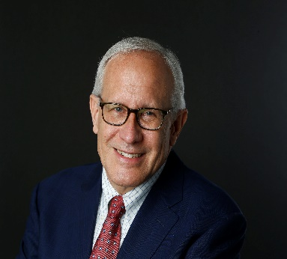
David McCraw, deputy general counsel, The New York Times
David McCraw has spent the last 17 years at The New York Times Company, where he serves as the newspaper's top newsroom lawyer. In that role he has been The Times’s principal legal advisor on the Wikileaks and Snowden disclosures and a range of Pulitzer Prize-winning stories, including the paper’s groundbreaking reporting on Donald Trump's tax returns, Harvey Weinstein, the contamination of America’s meat supply, and the secret fortunes of China's political elites.
He is the author of the book "Truth in Our Times: Inside the Fight for Press Freedom in the Age of Alternative Facts" (St. Martin's 2019), a first-person account of the legal battles that have helped to shape The Times’s coverage of the Trump years.
Mr. McCraw is one of the nation’s most active litigators of freedom-of-information lawsuits. Over the past decade, The Times has brought more than 65 FOIA cases against the federal government. The suits have led to the disclosure of previously secret records about the chemical weapons found in Iraq, the government’s legal justification for drone killings abroad, and the identities of companies and individuals allowed to trade with sanctioned nations.
His duties at The Times include acting as the company’s international crisis response manager. He oversaw the company’s response to the kidnapping of Times journalists in Afghanistan and the seizure of four other journalists by the Libyan government in the midst of the civil war and the emergency evacuation of reporters and photographers injured while covering conflict.
Mr. McCraw serves as a visiting lecturer at Harvard Law School and an adjunct professor at NYU Law School. He has been actively involved as a pro bono lawyer in efforts promoting press freedom around the world, including projects in Yemen, Montenegro, Georgia, Kuwait, Russia, and Cameroon.
He is a graduate of the University of Illinois, Cornell University, and Albany Law School. He began his career as a newspaper lawyer as deputy general counsel at the New York Daily News.

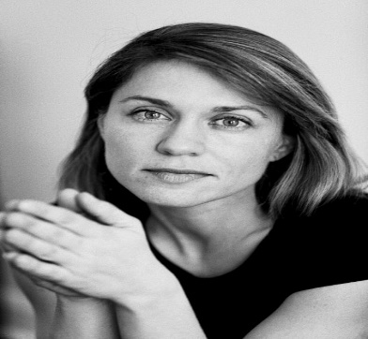
Andrea Bruce
Andrea Bruce is an award winning documentary photographer whose work focuses on people living in the aftermath of war. She concentrates on the social issues that are sometimes ignored and often ignited in war's wake.
Her clients include National Geographic and The New York Times as well as many publications around the globe. Andrea was a 2016 Nieman Fellow at Harvard University where she studied political theory and democracy.
Andrea started working in Iraq in 2003, bringing a local reporter’s knack for intimacy and community focus to the lives of Iraqis and the US military. For over ten years she has chronicled the world's most troubled areas, focusing on Iraq and Afghanistan.
For eight years she worked as a staff photographer for The Washington Post, where she originated and authored a weekly column called "Unseen Iraq.” She also worked at The Concord Monitor and The St. Petersburg Times after graduating from The University of North Carolina at Chapel Hill in 1995. She is now a member/ owner of the photo agency NOOR.
Her awards include the 2018 IWMF Anja Niedrinhaus award, a 2014 World Press Photo 2nd prize for Daily Life singles for the image ‘Soldier’s Funeral' and the inaugural Chris Hondros Fund Award in 2012 for the “commitment, willingness and sacrifice shown in her work.” In 2010 the White House News Photographers Association (WHNPA) awarded Andrea a grant for her work on conflict in Ingushetia. She has been named Photographer of the Year four times by the WHNPA, received several awards from the Pictures of the Year International contest, including the 2017 Environmental Vision Award, and was awarded the prestigious John Faber Award from the Overseas Press Club in New York.
Currently she is a CatchLight Fellow and a National Geographic Explorer and is based in North Carolina.

